Enhancement 1 - Software Design & Engineering
For this first enhancement, my plan included:
- Porting the existing code over to HTML & JS
- Breaking up the code into modules
- Adding visuals to the UI that replicate the original user requirements
- Adding a user “add”, “edit”, and “delete” option for a record
The original artifact was from a dashboard/database project from CS340: Advanced Programming Concepts (Client Server Development). The purpose of the dashboard requested by Grazioso Salvare was designed to allow the user to filter and display data based on specific animal criteria from the Austin Animal Center. The developed dashboard included a filterable table, four filters, a dynamic map, and a pie chart that updated along with the selected filters.
I selected this item for this enhancement because I felt confident that it would showcase my ability to develop a functioning site that had several dynamic components including a data table, a search and filter function, interactive map, and graph. Currently the site has two tabs, one for a main page (that I had updated to include real articles about pet care and links to resources), and the Austin Animal Center tab that holds the requirement pieces (see below screenshots). For this enhancement I was able to create a website utilizing parts of the MEAN stack where I could show that I am able to design and develop visual communications for the requested audience. I am also able to use innovative techniques and tools to improve upon a previous project.
I did meet my initial course outcomes that I had planned for this first enhancement. So far, I have achieved the following course outcome through the Enhancement Plan and Code Review in the previous modules: “Design, develop, and deliver professional-quality oral, written, and visual communications that are coherent, technically sound, and appropriately adapted to specific audiences and contexts”. This week I worked on achieving the outcome “Employ strategies for building collaborative environments that enable diverse audiences to support organizational decision making the field of computer science” through successfully recreating the dashboard into a dynamic page for users by porting the existing code over to HTML, JS, and CSS, while breaking up the code into more industry-standard modules. In addition, I was able to include the visual requirements for the client with the company’s logo, interactive table, pie chart, and dynamic map. In addition, I was able to utilize Angular and MongoDB so users can add, edit, or delete animals. With this artifact, I am demonstrating my ability to interpret and recreate customer requirements with different programming languages and techniques, use industry best practices by developing with modules and re-using correct code I had previously written for the same functionality, and incorporating new techniques like dynamic graphs and maps into a website.
This was a very difficult first enhancement and modification for the project. Most of the more complex changes I had planned were in this enhancement and what ultimately took up most of my time was deciding on how to get the requirements to be replicated in a new language. I had restarted several times but made breakthroughs by reviewing online resources and guides. Another challenge was finding out how to embed a table, dynamic pie chart, and interactive map since I hadn’t done that before in any of my classes. I was able to also connect to my MongoDB database and Angular server successfully for the next enhancements to be worked on correctly. This development laid the foundation for a successful transition from static dashboard to a functional website. This enhancement was a true test in patience and trial and error. I very quickly learned to work in small increments and check to see when the site breaks, so I know where to start to fix it.

(Original Dashboard Artifact)
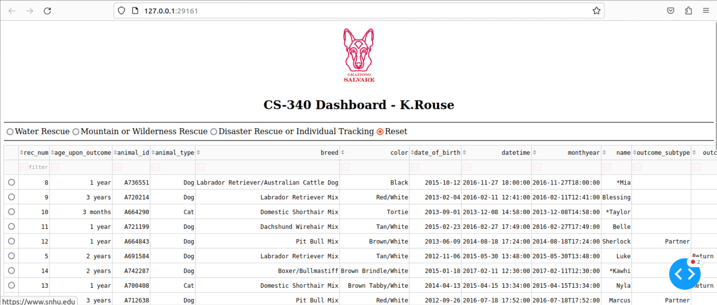
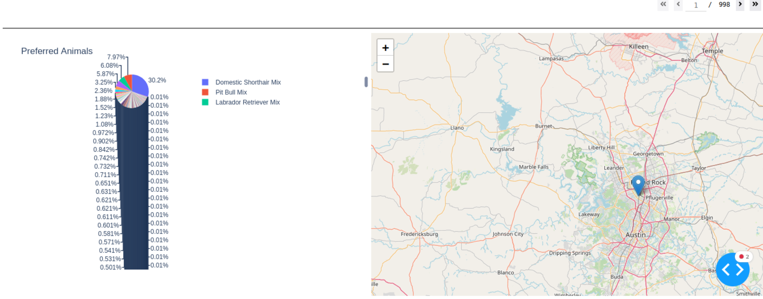

(Home page)
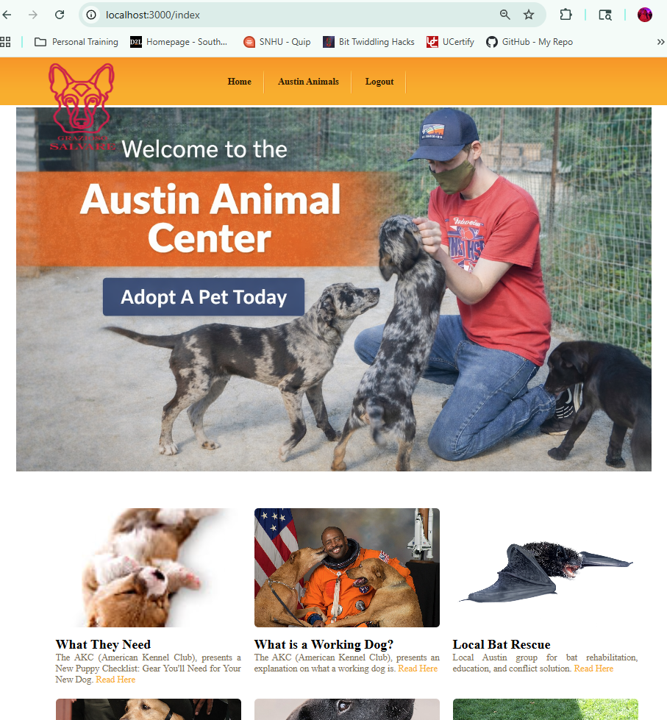
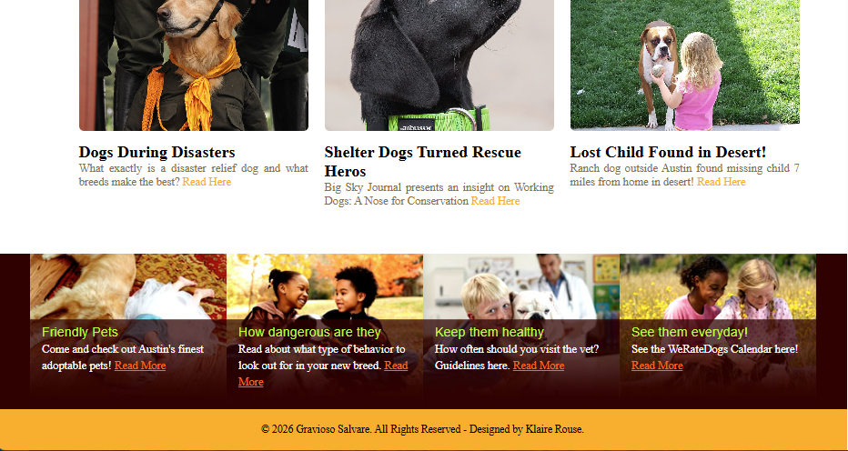
(Austin Animal Center)
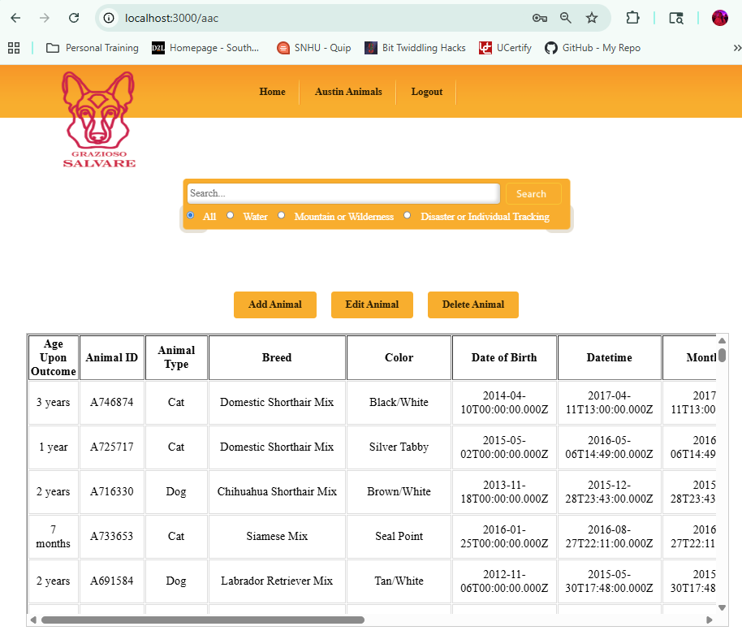
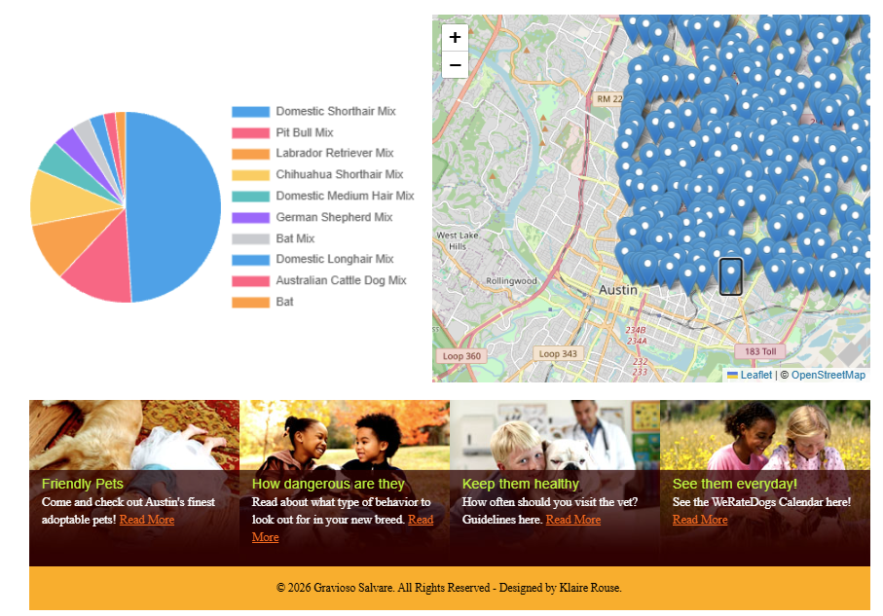
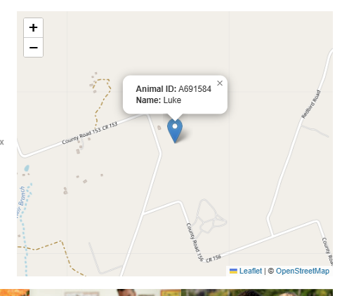**This is to show that if you select a single point or record from the table that it will go to that point with a popup message

(Add Animal Page)
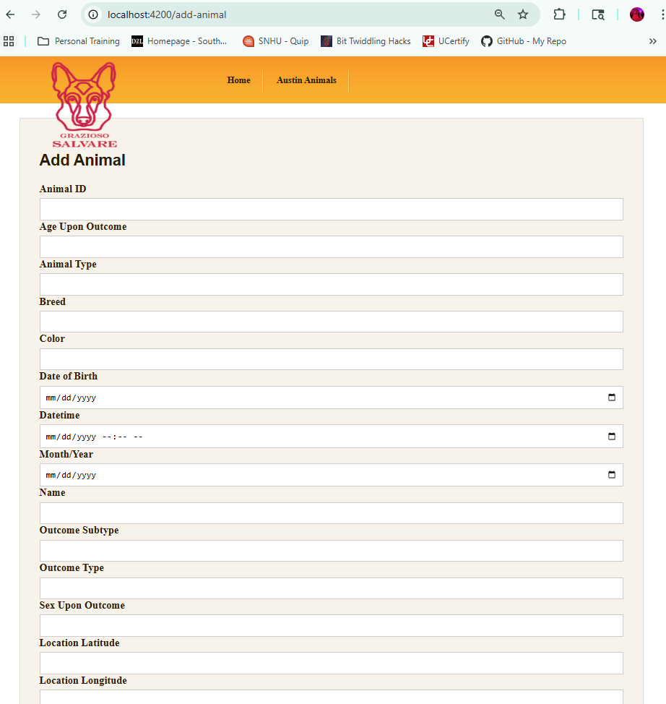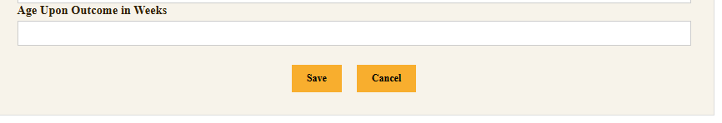
(Edit Animal Page)
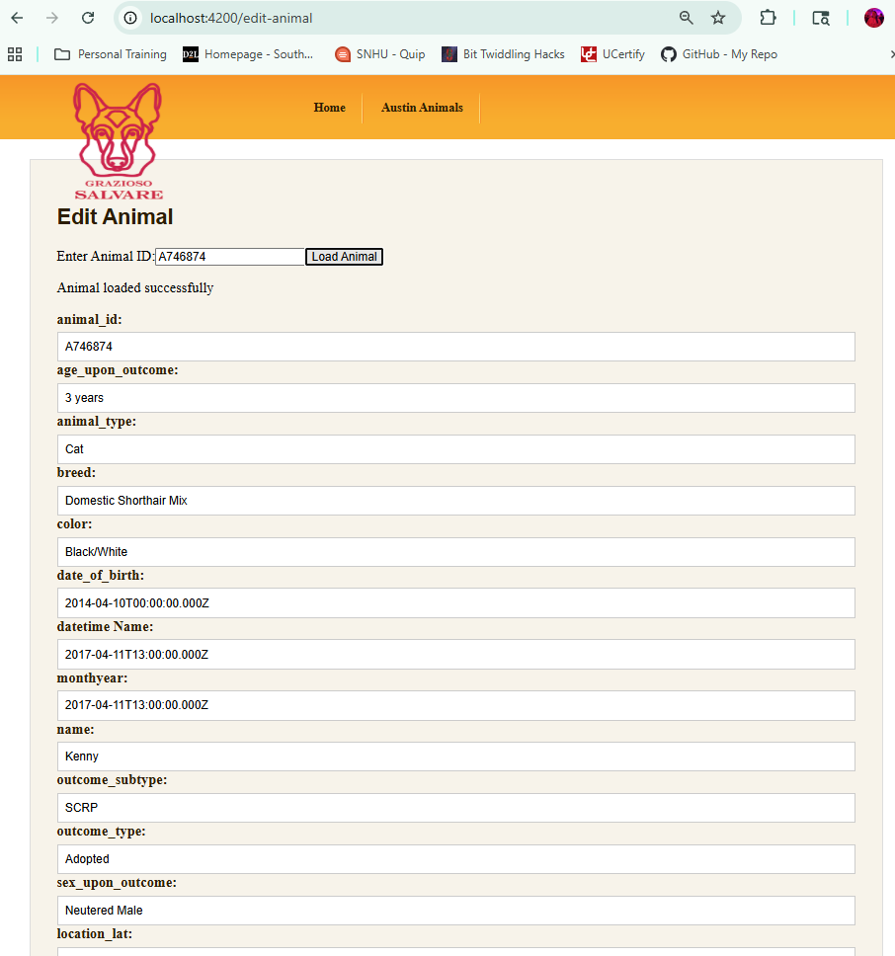
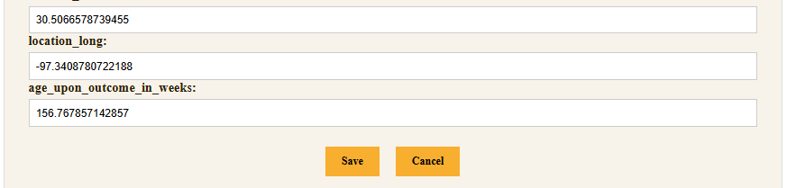
(Delete Animal Page)
